**Breaking the Glass Ceiling: A Comparative Analysis of Women's Advancement in Five Countries**

**- Poland, Germany, Sweden, Turkey and South Korea**

Kamila Bielecka,

Muhammed Melih Yıldız,

Ludvig Borges Månsson,

Minsu Lee,

Theresa Holand

Degree: Social Work

Course: Social Inclusion and Exclusion

Málaga, 10.05.2023

**Abstract**

The glass ceiling effect is a well-documented phenomenon that refers to the barriers and restrictions that prevent women and other minority groups from reaching higher positions in the workplace. This paper aims to provide a short overview of the Glass Ceiling Effect in general and its impact on women in particular. It also examines the extent to which the glass ceiling is prevalent in five different countries: Poland, Germany, Sweden, Turkey and South Korea.

To begin with, the paper defines the potential origin of the glass ceiling effect and discusses its various forms and expressions. The factors that contribute to its existence, such as discrimination, bias, and stereotyping, are also explored. Furthermore, a short definition of Leading Roles is provided.

The subsequent section focuses on the selected five countries and evaluates the prevalence of the glass ceiling effect in each country. For each country, a brief introduction is given, followed by a detailed analysis of data and statistics concerning Average Age of giving Birth, Education, Unpaid, labour and Quotas for women in Leading Roles.

It concludes by summarising the main findings and highlighting the need for further efforts to eliminate the glass ceiling in all countries. It also identifies opportunities for actions and initiatives that could help to eliminate the glass ceiling and promote greater gender equality in the workplace.

**Key Words**: glass ceiling effect, gender wage gap, gender equality, career, women

INDEX

**1. Introduction** **2**

**2. Objectives** **2**

**3. Theoretical Framework** **2**

3.1. Definition of Glass Ceiling 2

3.2. Leading Roles 3

**4. Methodology** **3**

**5. Results** **4**

5.1. Poland 4

5.2. Germany 6

5.3. Sweden 7

5.4. Turkey 9

5.5. South Korea 11

**6. Discussion** **12**

6.1. Age of Giving Birth and Birth Rate 12

6.2. Education 13

6.3. Unpaid Labour 13

6.4. Quotas for Women in Leading Roles 14

**7. Conclusion** **15**

**8. Bibliography** **16**

**9. Appendix** **17**

# 

# **Introduction**

Many public companies around the world have addressed ESG issues to foster growth. While they have tackled a variety of challenges, there are still areas that require more effort. One common problem worldwide is the low representation of women in leading roles.

This report analyzes the glass ceiling and leading roles in this project and researched and compared related materials in Sweden, Turkey, Germany, South Korea, and Poland. The glass ceiling refers to the environment where qualified women cannot occupy higher positions due to discrimination, and leading roles mainly refer to roles such as CEOs and executives.

This report introduces and compares the glass ceiling and leading roles phenomena in each country. As a result, it was found that the lower the birth rate, the better work opportunities were given to women, and it was revealed that women mainly participate in more unpaid labour than men.

# **Objectives**

The objective of this research paper is to analyze the concept of the glass ceiling in Sweden, Turkey, Germany, South Korea, and Poland. Specifically, the paper aims to achieve two objectives. Firstly, it will analyze theories related to the glass ceiling phenomenon in women's leadership. Secondly, it will examine the percentage of women in leadership positions in companies or businesses, and the number of women who have broken through the glass ceiling. The research questions that correspond to these objectives are: "What is the concept of the glass ceiling?" and "What is the quantitative data on the number of women in leadership roles?" Through the analysis of these objectives and research questions, the study aims to contribute to the understanding of the glass ceiling phenomenon and inform potential strategies to address it.

# **Theoretical Framework**

## **Definition of Glass Ceiling**

The glass ceiling is a term used to describe the phenomenon where a qualified individual, who seeks to advance within their organization's hierarchy, is prevented from reaching higher levels due to discrimination, often based on factors such as gender or race. The concept primarily focuses on gender discrimination against women in corporate settings. Defining the glass ceiling can be challenging due to the various interpretations and approaches associated with it, as well as the absence of clear, observable criteria to definitively determine its existence within a company (Jackson and O'Callaghan, 2009). However, numerous studies suggest that the glass ceiling refers to subtle yet persistent barriers and obstacles, rooted in discriminatory practices, both conscious and unconscious, that impede qualified women from accessing senior management positions (Zeng, 2011).

Li and Leung state that this term refers to discriminatory barriers that hinder women from reaching positions of power or responsibility and advancing within an organization solely because they are women (Li and Leung, 2001).

The term may have been coined by Marilyn Loden, an American writer and management consultant. She used this metaphor while speaking as a panelist at the 1978 Women's Exposition in New York. It gained significant momentum in 1986 when columnists Carol Hymowitz and Timothy Schellhardt used it in a special report in the Wall Street Journal titled "The Glass Ceiling: Why Women Can't Seem to Break the Invisible Barrier that Blocks Them from the Top Job." Since then, "glass ceiling" has become a widely used term in discussions about the challenges women face in advancing their careers.

The term gained further recognition and legitimacy with the enactment of the Glass Ceiling Act in the United States in 1991. By 1993, it was formally included in the Merriam-Webster Collegiate Dictionary. The Glass Ceiling Act established a Commission tasked with examining the advancement opportunities for women and minorities in management and decision-making roles (U.S. Glass Ceiling Commission, 1995). The Commission itself defines glass ceiling as an “unseen, yet unbreachable barrier that keeps minorities and women from rising to the upper rungs of the corporate ladder, regardless of their qualifications or achievements” (U.S. Glass Ceiling Commission, 1995, p. 4).

Elacqua et al. developed a model to explain the glass ceiling phenomenon, which is the barrier that prevents women from advancing to top positions in their organizations. In their study, the authors investigated why women managers are underrepresented in the highest levels of their organization, using a sample of 685 managers from a large Midwestern insurance company. The authors proposed a model where beliefs about organizational factors of an interpersonal and situational nature were linked to perceptions of differential treatment between men and women, which in turn, contributed to the perception of a glass ceiling. As a result, the authors concluded that perceptions of differential treatment serve as a mediator between both organizational factors (interpersonal and situational issues) and perceptions of the glass ceiling (Elacqua et al., 2009).

## **Leading Roles**

There are several types of lead positions in companies such as business executives, CEO´s, board members and many more.

These terms refer to someone in a high position in an organisation, who is thought to make decisions and to put them into action. (Indeed 2023) It also contains the capability to manage and guide employees in an organisation, to review done work and to give feedback. Mostly they oversee business activities as the achievement of the organisational goals, the strategic planning and decision making in general. (Cole 2015)

# **Methodology**

This study compares perceptions of women in leadership roles and the prevalence of the glass ceiling phenomenon in Sweden, Turkey, Germany, South Korea, and Poland. The research question guiding this study is: How do people in these countries view women in leadership, and what is the extent of the glass ceiling?

Inclusion criteria include peer-reviewed studies published between January 2010 and January 2023 in any language. Eligible studies must focus on women in leadership in at least one of the five countries across various sectors, and provide either quantitative or qualitative data.

The search strategy will use a combination of English and translated keywords to search electronic databases, including Google Scholar, JSTOR, and Scopus. Data will also be taken from verified and reliable databases, such as Eurostat, OECD database and similar sources. Two researchers will screen titles and abstracts to determine eligibility, with disagreements resolved by a third researcher.

Data extraction will include country of origin, sector investigated, and opinions expressed by participants. Qualitative content analysis will compare data across studies.

To focus the study on key factors that may impact the glass ceiling phenomenon, the authors identified four measurable variables: unpaid labour, average age of giving birth and birth rate, education level, and quotes for women in leadership roles. These factors were selected based on their perceived importance in relation to the glass ceiling across all countries studied.

Each of the five countries under investigation was analyzed for the four factors listed above. The study seeks to examine how these factors relate to perceptions of women in leadership roles and the prevalence of the glass ceiling in each country.

Results will be reported in a written report, describing commonalities and differences across studies and their implications for women in leadership. Areas for future research will also be identified.

# **Results**

## **Poland**

The position of women in employment continues to be one of discrimination, as observed in many workplaces, including Poland. Despite advances in technology, globalization, and changes in societal values, women's position in employment remains less significant than that of men. The 2020 Global Gender Gap Report projects that women in Central and Eastern Europe will not achieve equal economic, legal, and social status and opportunities until 2128, or in 107 years. Although discrimination based on gender, age, disability, religion, and nationality is prohibited in Poland, it still occurs in the workplace. Employers may be hesitant to promote women or invest in their training, fearing that they will resign from employment to start a family ((Kalinowska-Nawrotek 2005).

The Constitution of the Republic of Poland guarantees equal treatment and protection against discrimination by public authorities. It (Article 32(1)) emphasizes gender equality in family, political, social, and economic life. However, despite these provisions, discrimination against women based on gender remains a common phenomenon, primarily encountered in the workplace and at home. Discrimination against women in employment begins with employment denial, especially for fear of pregnancy. Women face discrimination at various stages of employment, such as unequal pay, unequal allocation of duties, and lack of pension security (Smyła 2015). Discrimination is based on the assumption that women prioritize family over professional life, have lower qualifications, or are not career-oriented (Znańska-Kozłowska 2012).

In 2019, a Eurostat study revealed that women held 47% of managerial positions in Poland, making it the second highest among European countries. However, this does not necessarily indicate the absence of a glass ceiling in Poland. Another finding of the study shows that women only occupy 13% of management and supervisory positions in the largest companies listed on the stock exchange. This is below the EU average of 17% (Women in Business 2020).

Despite expert opinions suggesting that prejudices and long-held beliefs are responsible for the underrepresentation of women in high positions in Poland and around the world, a 2021 LiveCareer survey titled "Woman Boss" challenges this thesis. The survey, which involved over 700 respondents, shows that 78% of Poles believe that gender is not a factor when it comes to filling managerial positions, indicating that prejudice may not be the root cause.

Interestingly, the positive perception of women in managerial positions is more prevalent in small and medium-sized companies, where 38% of top management positions are held by women. This is the highest percentage in Europe. So, if prejudice is not the reason, what could be the cause of the limited representation of women in high positions in Poland and other countries?

In this study, the authors analyzed several factors that may contribute to the occurrence of the "glass ceiling" phenomenon in Poland. The data used for this analysis were obtained from current and reliable statistical sources, and the results are presented in the following section.

**Average Age of Giving Birth and Birth Rate**

One of the factors taken into account was the fertility rate in the country. In Poland, the fertility rate is 1.4, which is slightly lower than the EU average of 1.5, according to 2020 data (World Bank Open Data, 2020). Additionally, the average age of childbirth in Poland is 29.9 years, and the average age at which a Polish woman gives birth to her first child is 28.1, as of 2021 (Eurostat)

**Education**

Another aspect that could influence women's prospects of advancement was considered: the state of higher education among women in Poland. According to 2020 data, 31.2% of women aged 25 or older in Poland have pursued higher education, including at least a bachelor's degree, which is a significantly higher percentage than men. The gender gap in this regard is over 6%. This correlation is intriguing because despite more women in Poland obtaining higher education, men still predominantly occupy managerial roles (UNESCO Institute for Statistics (UIS)).

**Unpaid labour**

It has been discovered that a significant hindrance to women's career advancement may be the unpaid domestic work they perform daily. It is often assumed that women will naturally take care of household chores such as cooking, cleaning, and child-rearing. According to 2022 data, women spend more than 200 minutes daily on unpaid work, while men spend less than 2.5 hours. On average, Polish men work (paid work) for approximately 315 minutes a day, while women work for more than 200 minutes. Consequently, women end up dedicating more time to work overall (about 500 minutes) than men, who spend around 470 minutes a day working (OECD).

## **Germany**

In the annual Global Gender Gap Report of the World Economic Forum, Germany ranked 11th out of a total of 156 countries in 2021. Although it has succeeded in narrowing the gender gap compared to 2006, its positioning in the global ranking has deteriorated since then. In 2006, Germany was still in 5th place. This relative deterioration is due to the fact that other countries were able to make greater progress towards more equality in the same period. For example, the proportion of women in senior management is currently 27% and has been more or less the same since 2008. (Albrecht and Rude, 2022)

**Average Age of Giving Birth and Birth Rate**

The birth rate per woman in Germany is 1.5 (World Bank Open Data, 2020) and thus corresponds to the average in the EU. The average age at which women give birth to their first child is 31.5 years (Eurostat, 2021).

**Education**

In preschool, primary and secondary education, Germany compares very favourably with other countries in terms of gender equality. In higher education, on the other hand, it does not. This is especially true for the choice of field of study. More than 50% of German men graduate in STEM related subjects, while only two out of ten women do so which leads to 34.9% fewer women completing a STEM degree than men. (Albrecht and Rude, 2022)

**Unpaid labour**

In Germany, women perform a disproportionate share of unpaid domestic work. This amounts to 242.3 minutes per day, which is 16.8% per day. Men, on the other hand, spend only 10.4% of their day on unpaid labour. The picture is reinforced if we look at the average weekly hours worked by male and female parental couples. In 2019, fathers work an average of 23.5% more than mothers (Albrecht and Rude, 2022).

Aspects that reinforce or mitigate a glass ceiling include presence in the workplace and a high degree of mobility. Presence and mobility are seen as a sign of commitment and achievement. (Weissenreider et. al. 2017) Part-time and alternating work models, in turn, are predominantly used by women (Statistisches Bundesamt 2013).

Therefore, these work models can have a negative impact for women who want to break the glass ceiling, as the previously mentioned aspects such as presence and mobility are not fulfilled due to the also previously mentioned larger share of unpaid labour performed by women at home.

**Quotas for Women in Leading Roles**

In 2015, a german law was introduced called “Gesetz für die gleichberechtigte Teilhabe von Frauen und Männern an Führungspositionen in der Privatwirtschaft und im Öffentlichen Dienst” which can be translated into “Act for the Equal Participation of Women and Men in Leadership Positions in the Private and Public Sector”. It stipulates that at least 30 percent of the seats on supervisory boards of listed companies newly filled as of 2016 must be taken by women. This currently involves 105 companies in Germany. Other private-sector companies in Germany, those not listed on the stock exchange, must set their own targets for increasing the proportion of women on supervisory boards, management boards and upper management levels. However, the target rate must not fall below the current level. (Thumm, Kuhn 2020)

It can be said that Germany is striving for equality and also supports this with a legal quota, but that there is nevertheless a stable glass ceiling.

## **Sweden**

**Birth Rate and Average Age of Giving Birth in Sweden**

To find information regarding this topic, the database from the World Bank (2020) is a good and reliable source. The database has been modified to match the specific demands of retrieving information about education and gender equality in Sweden.

According to the database, Sweden's fertility rate has been declining steadily over the past several decades. In 1960, the fertility rate in Sweden was about 2.5 children per woman. By 2020, it had dropped to around 1.7 children per woman.

The fertility rate is an important indicator of a country's population growth and can have significant implications for social and economic development. In Sweden, the declining fertility rate has been attributed to a variety of factors, including increased access to family planning services, greater gender equality, and changes in cultural norms around family size.

**Education**

Like the paragraph above, the information here has been gathered from The World Bank (2020).

The page shows the percentage of the labour force with at least a bachelor's degree or equivalent education, broken down by gender. In 2020, 28% of Sweden's labour force with this level of education were female, while 72% were male (The World Bank, 2020). This indicates that while there is still some gender disparity in the labour force with advanced degrees, the situation is relatively equitable compared to many other countries.

The World Bank (2020) also includes a chart showing the percentage of women with at least a bachelor's degree or equivalent education in Sweden over time. The chart indicates that the proportion of women with this level of education has been steadily increasing over the past decade, from around 24% in 2010 to around 28% in 2020.

**Unpaid Labour**

To gather information about unpaid labour for women in Sweden, We are looking at a database from the Organisation for Economic Co-operation and Development (OECD, 2020)

According to the database (2022), women in Sweden spend an average of 249 minutes per day on unpaid work, such as housework, caregiving, and volunteering, while men spend an average of 178 minutes per day. This gender gap of 71 minutes is smaller than the OECD average, which is 101 minutes.

The data also indicates that women in Sweden spend an average of 137 minutes per day on unpaid care work, such as caring for children or elderly relatives, while men spend an average of 68 minutes per day on this type of work. This gender gap of 69 minutes is also smaller than the OECD average of 96 minutes (OECD, 2022).

**Quotas and Laws for Women in Leading Roles**

Sweden has a number of laws and policies in place aimed at promoting gender equality and addressing the glass ceiling phenomenon in the workplace. Here are a few examples:

* The Discrimination Act (Swedish Government, 2008): This law prohibits employers from discriminating against employees on the basis of gender, among other protected characteristics. It also requires employers to take active measures to promote equal opportunities for men and women in the workplace.
* The Gender Equality Act (Swedish Gender Equality Agency, 1979): This law requires employers to take steps to promote gender equality, including by conducting regular gender equality analyses and developing action plans to address any disparities. It also requires employers to provide equal pay for equal work, regardless of gender.
* The Parental Leave Act (Swedish Government, 1995): This law provides for paid parental leave for both mothers and fathers, allowing them to take time off work to care for a new child without fear of losing their job.
* The Swedish Corporate Governance Code (Swedish Government, 2004): This code provides guidance to companies on how to promote diversity and gender equality on their boards and in their executive teams.

These laws and policies reflect Sweden's commitment to promoting gender equality and addressing the glass ceiling phenomenon in the workplace. However, as with any set of laws, their effectiveness depends on how well they are enforced and implemented in practice.

## **Turkey**

The "glass ceiling" phenomenon remains a significant challenge for women in Turkey who aspire to reach top positions in their careers. Despite progress made in recent years, there are still significant disparities between men and women in the workforce. Traditional gender roles, biassed attitudes, and limited access to opportunities continue to hinder women's advancement in the workplace.

One of the significant factors contributing to the "glass ceiling" in Turkey is the prevalence of traditional gender roles. Women are often expected to take care of household duties and child-rearing, which can significantly impact their ability to dedicate time to their careers. According to the Turkish Statistical Institute's (TÜİK) data, the labour force participation rate of women in Turkey is only 32.8%, compared to 70.3% for men. This gap is due in large part to the disproportionate burden of unpaid labour that women bear, which limits their availability for paid work.

**Average Age of Giving Birth and Birth Rate**

It is indeed that having children affects women's business life. In Turkey the birth rate per woman is 1.9 (World Bank Open Data, 2020). According to the Turkish Statistical Institute (TÜİK) the average age of mothers giving birth for the first time is 29.1 (2021).

**Education**

Furthermore, women in Turkey face challenges related to education and employment. According to the United Nations Development Programme (UNDP), the primary school completion rate for girls in Turkey is 89.4%, compared to 95.4% for boys. Additionally, the proportion of women with tertiary education is only 20%, compared to 32% for men. These disparities in education can significantly limit women's opportunities for professional development and advancement.

**Percentage in Leading Roles**

Another factor that contributes to the "glass ceiling" phenomenon in Turkey is the biased attitudes towards women in the workplace. Despite significant progress made in recent years, gender stereotypes still persist, and women are often perceived as less competent or less committed to their careers. These biases can prevent women from being given the same opportunities or recognition as their male colleagues. According to TÜİK's 2021 data, only 20.7% of senior executives in Turkey are women. In 2012 it was 14.4%. Within nearly 10 years this improvement does not seem enough.

**Unpaid Labour**

Moreover, the burden of unpaid labour falls disproportionately on women in Turkey. According to the OECD, women in Turkey spend an average of 305 minutes per day on unpaid labour, such as household chores and caring for children or elderly family members. In contrast, men in Turkey spend only 67.6 minutes per day on such activities. This disparity in unpaid labour creates an additional barrier for women who aspire to advance in their careers.

**Quotas and Laws for Women in Leading Roles**

* The principle of equality is also expressed in the 10th and 55th articles of the Constitution, and in the 10th article, "everyone, language, colour, gender, political thought, philosophical are equal before the law without any discrimination based on belief, religion, sect and similar reasons”. The margin heading of Article 55 is “Ensuring Justice in Remuneration”. No discrimination based on gender the issue has been specifically determined in the Constitution.
* Men are paid more than women. The principle of "equal pay for equal work", which should be applied in working environments, is stated in the "equal pay" . It is also defined under the “principle of behaviour” (article 5). It has been tried to prevent the employer from taking “direct or indirect different actions due to gender or pregnancy”.
* Certain conditions for working women on maternity leave, defined as maternity leave presented below. According to Article 15 of the Law No. 5510, “In case of multiple pregnancy in the first eight weeks after the delivery from the date of pregnancy of the woman within the scope of Article 4 in the first ten-week period, discomfort and disability related to pregnancy and maternity state are considered maternity state.
* Maternity leave of civil servant women is also included in Article 104 of Law No. 657 edited. Accordingly, to the female officer; Maternity leave is given for a total of sixteen weeks, eight weeks before birth and eight weeks after birth.
* Breastfeeding allowance is an allowance paid to the woman. 5510 as stated in Article 16 of Law No. 4/a, insurance holders who want to benefit from this benefit, must pay at least 120 days of short-term insurance premium they must be reported.

To overcome the "glass ceiling" phenomenon and increase the representation of women in top positions, there needs to be a fundamental shift in societal attitudes towards women in the workplace. This can include increasing awareness of gender biases, implementing policies to support women's career development, and creating a more inclusive work environment. Companies can also work to address the unequal distribution of unpaid labour by implementing flexible work arrangements or offering parental leave and other family-friendly benefits.

In conclusion, while progress has been made in recent years, the "glass ceiling" phenomenon remains a significant obstacle for women in Turkey who aspire to reach top positions in their careers. Addressing the root causes of gender inequality in the workplace, including traditional gender roles, biased attitudes, and unequal distribution of unpaid labour, is essential to achieving gender parity in the workforce.

## **South Korea**

**Unpaid Labour**

The data provided by OECD indicates the amount of time spent by a man and a woman on paid and unpaid work. According to the figures, the man spent a total of 468 minutes, with 419 minutes spent on paid work and 49 minutes on unpaid work. On the other hand, the woman spent a total of 484.4 minutes, with 269.4 minutes spent on paid work and 215 minutes spent on unpaid work. The data highlights the disparity in the amount of time spent on unpaid work by the two individuals, with the woman spending significantly more time on unpaid work compared to the man. This is a common trend observed in many societies, where women are often burdened with the majority of unpaid work, such as household chores and childcare, which can limit their opportunities for paid work and career advancement.

**Average Age of Giving Birth and Birth Rate** (2022 OECD Korea economic report)

About the topic above, we have looked up the report which states Korea’s economy in 2022. The mean age of giving birth in South Korea has increased significantly over the past few decades, from 26.23 in 1993 to 32.20 in 2020, reflecting a shift towards delayed childbirth and lower fertility rates. Japan has also witnessed a similar trend, with the mean age of giving birth increasing from 27.2 in 1993 to 30.7 in 2020, indicating a decline in the number of births and an ageing population.

Between 2000 and 2020, the birth rate in South Korea declined from 1.48 to 0.84, reflecting a low birth rate and an ageing population.

**Education**

The ratio of people over the age of 25 in South Korea who hold a bachelor's degree is an important indicator of educational attainment and workforce readiness. According to the data provided, the overall percentage of individuals who have completed a bachelor's degree stands at 28.7%, with men outpacing women by a significant margin. While 33.4% of men in this age group have completed a bachelor's degree, only 24.1% of women have done so. This gender gap is significant, with men being 9.4% more likely to hold a bachelor's degree than women.

**Quotas and Laws for Women in Leading Roles**

"Percentage of Women Executives" (Source: Ministry of Gender Equality and Family)

This material provides statistics on the representation of women in executive positions in South Korea for the first quarter of 2021. Out of a total of 32,005 executives in 2,246 listed companies, only 1,668 (approximately 5.2%) were women. This represents a slight increase from 2020, where the percentage was 4.5%. In comparison, the average percentage of women executives among OECD countries was 25.8% in 2021.

The data also shows that out of the 1,668 female executives, they account for only 0.4% of the total female employees (406,631) in listed companies, whereas male executives account for 2.6% of the total male employees (1,181,047). This indicates a significant gender imbalance in executive positions in South Korea.

# **Discussion**

## **Age of Giving Birth and Birth Rate**

From a glass ceiling perspective, the fertility rate and average age of childbirth can be seen as important factors that affect women's opportunities for career advancement. In general, countries with lower fertility rates tend to have a higher proportion of women in the workforce and better opportunities for women's career advancement.

Looking at the countries mentioned, Poland and Germany both have relatively low fertility rates, which suggests that there may be more opportunities for women to participate in the workforce. However, the average age of childbirth is significantly higher in Germany than in Poland, which may suggest that women in Germany face greater challenges balancing family responsibilities with career advancement.

Sweden's declining fertility rate, which has been attributed to greater gender equality and changes in cultural norms, may suggest that women in Sweden have more opportunities for career advancement. However, it is also important to note that Sweden has long been considered a leader in gender equality and has implemented policies such as parental leave that support women's participation in the workforce.

Turkey has a relatively higher fertility rate compared to the other countries mentioned, which may suggest that women in Turkey face greater challenges balancing family responsibilities with career advancement. However, the average age of childbirth is similar to Poland, which may indicate that women in Turkey have more opportunities to participate in the workforce at a younger age. It is also important to note that Turkey has been criticized for its lack of progress in gender equality, with women facing discrimination in the workplace and limited opportunities for career advancement.

Adding South Korea to the analysis, we can see that the mean age of giving birth has significantly increased over the past few decades, reflecting a shift towards delayed childbirth and lower fertility rates. The birth rate in South Korea declined from 1.48 in 2000 to 0.84 in 2020, indicating a low birth rate and an ageing population. These trends can have significant implications for social and economic development in the country, as well as for women's career prospects. Women in South Korea have historically faced significant barriers to advancing in the workplace, including gender discrimination, unequal pay, and a lack of support for work-life balance. The combination of a low birth rate and an ageing population could exacerbate these issues, as a shrinking workforce may lead to increased competition for jobs and a lack of support for family-friendly policies in the workplace.

Overall, while the fertility rate and average age of childbirth can provide some insight into women's opportunities for career advancement, it is important to consider a range of factors, including cultural norms, policies, and workplace practices, that may impact women's experiences in the workforce.

## **Education**

Looking at the education systems of Sweden, Germany, Turkey, and Poland from a glass ceiling perspective, it's clear that the level of gender equality varies significantly between these countries.

In Sweden, while there is still some gender disparity in the labour force with advanced degrees, the situation is relatively equitable compared to many other countries. The proportion of women with at least a bachelor's degree or equivalent education has been steadily increasing over the past decade, indicating progress in gender equality in education and the workforce.

In Germany, there is a significant gender gap in higher education, especially in the choice of field of study. More than 50% of German men graduate in STEM-related subjects, while only two out of ten women do so, leading to fewer women completing a STEM degree than men. This gender gap in higher education could contribute to the under-representation of women in leadership positions and limit their opportunities for advancement.

In Turkey, women face challenges related to education and employment, with a lower proportion of women having tertiary education compared to men. These disparities in education can significantly limit women's opportunities for professional development and advancement.

The disparity in educational attainment between men and women in South Korea can be attributed to a variety of factors, including cultural and societal norms that may discourage women from pursuing higher education or limit their access to educational opportunities. Furthermore, women in South Korea may face a number of challenges that make it more difficult for them to complete a bachelor's degree, such as family responsibilities or workplace discrimination.

In Poland, despite more women pursuing higher education, men still predominantly occupy managerial roles, indicating a persistent glass ceiling effect. The higher education gender gap in Poland is over 6%, which could contribute to the under-representation of women in leadership positions.

These examples highlight the importance of addressing gender inequality in education to break the glass ceiling and improve women's opportunities for professional development and advancement.

## **Unpaid Labour**

From a glass ceiling perspective, the data presented in the article shows that the burden of unpaid labour falls disproportionately on women across different countries, reinforcing the glass ceiling effect, which makes it harder for women to break through to higher levels of management.

In Turkey, where women spend an average of 305 minutes per day on unpaid labour, compared to only 67.6 minutes for men, the glass ceiling effect is likely to be even more pronounced, as women are limited in their ability to work longer hours and take on additional responsibilities at work. This could explain why women are underrepresented in leadership positions in Turkey.

In Sweden, where the gender gap in unpaid labour is smaller than the OECD average, and women spend an average of 137 minutes per day on unpaid care work, compared to 68 minutes for men, the glass ceiling effect is likely to be less pronounced. This could explain why Sweden has a higher percentage of women in leadership positions compared to other countries.

In South Korea, the burden of unpaid labour falls disproportionately on women, with women spending an average of 215 minutes per day on unpaid care work compared to only 49 minutes for men. This reinforces the glass ceiling effect and limits women's opportunities to break through to higher levels of management. The trend of women being burdened with unpaid work is a common one in many societies, and it can be a significant barrier for women who aspire to advance in their careers. In South Korea, this can be compounded by the country's low birth rate and ageing population, which places additional pressure on women to balance work and caregiving responsibilities.

In Germany and Poland, where women perform a disproportionate share of unpaid domestic work, this creates a significant barrier for women who aspire to advance in their careers. The prevalence of part-time and alternating work models, which are predominantly used by women, can also have a negative impact on women's career advancement, as they do not fulfil the aspects of presence and mobility that are seen as a sign of commitment and achievement.

The data presented in the article suggests that reducing the gender gap in unpaid labour is crucial for breaking the glass ceiling and improving women's representation in leadership positions. This could be achieved through policies and initiatives that encourage men to take on more household and caregiving responsibilities, as well as providing support for working parents, such as affordable childcare and flexible work arrangements. By reducing the burden of unpaid labour on women, we can create a more level playing field for women in the workplace and help them achieve their full potential.

## **Quotas for Women in Leading Roles**

From a glass ceiling perspective, the comparison between Turkey, South Korea, Sweden, Germany, and Poland in terms of quotas and laws for women in leading roles highlights some interesting observations.

In Turkey, although the Constitution expressly prohibits discrimination based on gender, there is still a gender pay gap, which indicates the existence of a glass ceiling preventing women from advancing to higher positions. Maternity leave is protected by law, but it remains unclear whether employers are taking active measures to promote equal opportunities for women in the workplace.

In contrast, Sweden has a comprehensive legal framework that promotes gender equality, including laws that prohibit discrimination against women and require employers to take active measures to promote gender equality in the workplace. The Parental Leave Act ensures that both mothers and fathers have access to paid leave, which helps to reduce the burden on women and allows them to continue their careers. The Swedish Corporate Governance Code also encourages companies to promote diversity and gender equality on their boards and in their executive teams.

Similarly, Germany has a legal quota that requires companies to have at least 30% of women in supervisory board positions. However, it is worth noting that there is still a glass ceiling despite this legal quota, indicating that more needs to be done to address the underlying causes of gender inequality in the workplace.

In Poland, despite constitutional guarantees of equal treatment and protection against discrimination, discrimination against women based on gender remains a common phenomenon, particularly in the workplace and at home. Discrimination starts with the denial of employment, especially for fear of pregnancy. Women face discrimination at various stages of employment, such as unequal pay, unequal allocation of duties, and lack of pension security. The assumption that women prioritize family over their professional life, have lower qualifications, or are not career-oriented is the basis for this discrimination.

It is clear that while Poland has taken some steps to address gender inequality, such as the constitutional guarantees of equal treatment and protection against discrimination, there is still a long way to go. The persistent discrimination against women in the workplace, including the glass ceiling, highlights the need for more comprehensive laws and policies to promote gender equality.

South Korea has Ministry of Gender Equality and Family which is doing effort for including women in workplaces and leading roles. Compared to 2020 there is significantly increase by 0.7% but compared to other countries South Korea has lowest percentage. Most closest with South Korea is Turkey by 20.7% and OECD countries’s average is 25.8%. Data also shows that only 0.4% of the total female employees is working in leading roles. This shows South Korea still has a long way to go.

The comparison of the different quotas and laws for women in leading roles in Turkey, Sweden, Germany, and Poland demonstrates the different approaches taken by each country to address gender inequality and the glass ceiling phenomenon. While some countries have implemented comprehensive laws and policies to promote gender equality, others have only taken limited steps. However, the effectiveness of these laws and policies ultimately depends on how well they are enforced and implemented in practice.

# **Conclusion**

In conclusion, Despite significant progress towards gender equality, the concept of the glass ceiling remains a relevant issue in several countries around the world, including Sweden, Turkey, Germany, South Korea and Poland. The analysis of the glass ceiling in these countries highlights the pervasive nature of gender and other forms of discrimination in the workplace. Despite some progress towards gender equality, the glass ceiling remains a significant barrier that prevents women and other marginalized groups from advancing in their careers.

To address the glass ceiling, it is essential to understand its root causes. In this paper, it is analyzed how the "glass ceiling" looks like in the above-mentioned countries and what may be the causes of this phenomenon. These include the differences in unpaid labour, biased hiring practices, limited opportunities for development, and cultural attitudes that perpetuate stereotypes and discrimination.

Addressing these issues requires a comprehensive approach that involves policy reforms, cultural shifts, and changes in workplace practices. This may include measures such as affirmative action, flexible work arrangements, unconscious bias training, and the promotion of diversity and inclusion in the workplace and, above all, changes in the stereotypical thinking of society members that it is the woman who should prioritize taking care of the family and home. By recognizing and addressing the glass ceiling, societies can help create more inclusive and equitable workplaces for everyone.

# **Bibliography**

**Databases**:

Time spent in paid and unpaid labour (OECD database): ​​<https://stats.oecd.org/index.aspx?queryid=54757#>

Age of Giving Birth and Birth Rate:

<https://ec.europa.eu/eurostat/databrowser/view/tps00017/default/bar?lang=en> - Mean age of women at childbirth and at birth of first child (2 indicators)

Fertility rate: <https://data.worldbank.org/indicator/SP.DYN.TFRT.IN?locations=PL>

Education: [https://genderdata.worldbank.org/indicators/se-cuat-zs?education=At%20 least%20 Bachelor%27s%20 or%20 equivalent](https://genderdata.worldbank.org/indicators/se-cuat-zs?education=At%20least%20Bachelor%27s%20or%20equivalent) - Educational attainment by level of education, cumulative (% population 25+) (at least bachelor) - UNESCO Institute for Statistics (UIS).

**Theoretical Framework:**

* Jackson, F. L., and O’Callaghan, E. M. (2009). What do we know about glass ceiling effects? A taxonomy and critical review to inform higher education review.
* Zeng, Z. (2011). The myth of the glass ceiling: evidence from a stock-flow analysis of authority attainment
* Li, L., and Leung, R. W. (2001). Female managers in Asian hotels: profile and career challenges. *Int. J. Contemp. Hosp. Manag.* 13, 189–196.
* U.S. Glass Ceiling Commission. (1995). *A solid investment: Making full use of the nation’s human capital (final report of the Commission)*. Washington, DC: U.S. Government Printing Office.
* Elacqua, T. C., Beehr, T. A., Hansen, C. P., and Webster, J. (2009). Manager’s beliefs about the glass ceiling: interpersonal and organizational factors. Psychol. Women Q. 33, 285–294.
* Albrecht Clara, Rude Brita, (2022) Wo steht Deutschland 2022 bei der Gleichstellung der Geschlechter?. Leibniz-Institut für Wirtschaftsforschung an der Universität München e.V. <https://www.ifo.de/DocDL/sd-2022-albrecht-rude-geschlechtergleichheit-deutschland.pdf> (acessed 30 April 2023)
* Weissenrieder, C. O., Graml, R., Hagen, T., & Ziegler, Y. (2017). Ist die gläserne Decke noch aktuell? Untersuchung wahrgenommener Aspekte der Unternehmenskultur und der geschlechtsspezifischen Unterschiede in Karrierechancen. GENDER - Zeitschrift für Geschlecht, Kultur und Gesellschaft, 9(1), 115-132. https://doi.org/10.3224/ gender.v9i1.08 (accessed 1 May 2023)
* Thumm Johanna, Kuhn Sarah. (2020) Mehr Frauen in die Chefetagen – das Gesetz zur Frauenquote.Landeszentrale für politische Bildung Baden-Württemberg <https://www.lpb-bw.de/frauenquote-gesetz> (accessed 1 May 2023)
* Ben Cole, 2015, *Techtarget*, accessed 30 April 2023 <<https://www.techtarget.com/searchcio/definition/executive-leadership>>
* Indeed Editorial Team, 2023, *Indeed*, accessed 30 April 2023 <<https://www.indeed.com/career-advice/career-development/lead-position#:~:text=A%20lead%20position%20involves%20directly,handles%20higher%2Dlevel%20work%20items>>
* Kalinowska - Nawrotek B.,  *Dyskryminacja kobiet na polskim i europejskim rynku pracy oraz możliwości jej przezwyciężania,* “Zeszyty Naukowe / Akademia Ekonomiczna w Poznaniu”, 2005.
* Znańska-Kozłowska Katarzyna, Kobieta na rynku pracy a "szklany sufit", Zeszyty Naukowe Wyższej Szkoły Ekonomii i Informatyki w Krakowie, 2017, z. 13,.
* Swedish discrimination act, (2008) *Diskrimineringslag,* Accessed 2nd May 2023

<https://www.riksdagen.se/sv/dokument-lagar/dokument/svensk-forfattningssamling/diskrimineringslag-2008567_sfs-2008-567>

* Swedish parental leave act, (1995), *Föräldraledighetslagen,* Accessed 2nd May, 2023

<https://www.government.se/government-policy/labour-law-and-work-environment/1995584-parental-leave-act-foraldraledighetslagen/>

* Swedish code of corporate governance, (2004), *Swedish Code of Corporate Governance,* Accessed 2nd May, 2023.

<https://www.government.se/legal-documents/2004/04/sou-200446/>

* Swedish Gender Equality Act, (1979), *Gender Equality Policy in Sweden,* Accessed 2nd May, 2023.

<https://swedishgenderequalityagency.se/gender-equality-in-sweden/#:~:text=1979%20The%20Gender%20Equality%20Act&text=Men%20and%20women%20were%20formally,The%20law%20is%20gender%20neutral>.

# **Appendix**

* 1. **Average Age of Giving Birth and Birth Rate**

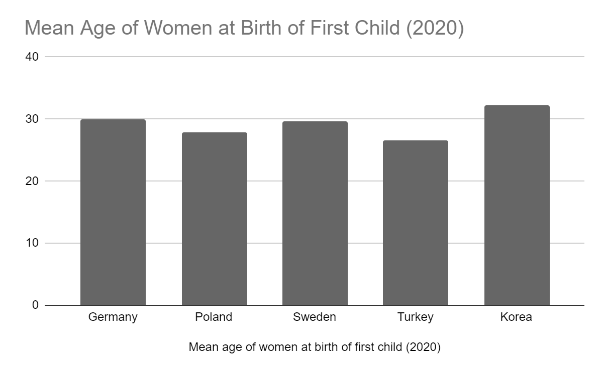

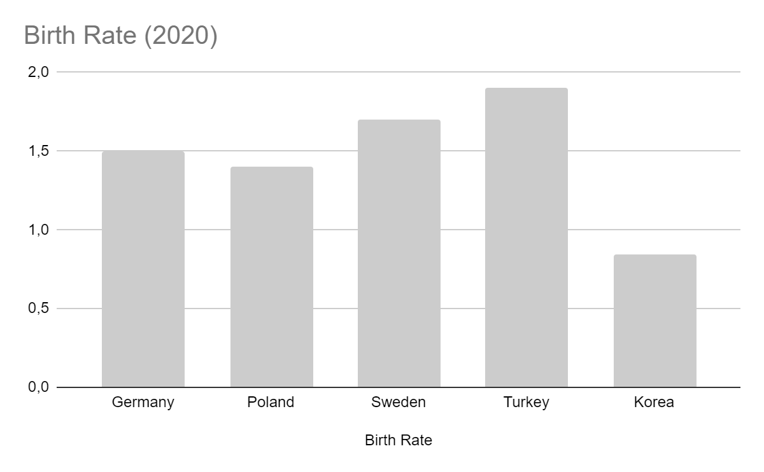

Source (Germany, Poland, Sweden and Turkey): Eurostat 2020

Source (Korea): OECD Family Database <https://www.oecd.org/els/soc/SF_2_3_Age_mothers_childbirth.pdf>

(accessed: 06.05.2023)

* 1. **Education**

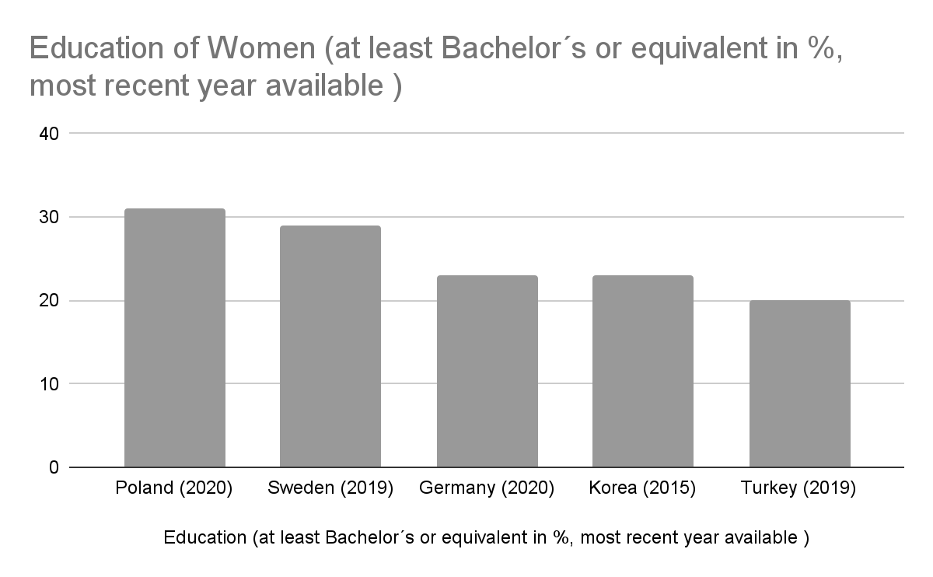

Source (Poland, Sweden, Germany, Korea): The World Bank

Source (Turkey): <https://www.oecd.org/education/education-at-a-glance/EAG2019_CN_TUR.pdf> (accessed: 06.05.2023)

* 1. **Unpaid Labour**

